

f

|  |
| --- |
| 1-1-2  بولتن کودکان  هفته دوم |
| موضوعات  مقاله هفته 2  عنوان فارسی 2  عنوان لاتین 2  اطلاعات هفته 3  علائم پنومونی شدید با شروع دیررس چیست؟ 3  کتاب هفته 4 |
| شهریور 1404  بیمارستان کودکان امام حسین  کتابخانه دکتر محمود بهشتی |



کتابخانه دکتر محمود بهشتی

# مقاله هفته

|  |
| --- |
| عنوان فارسی ارزیابی نقش پروبیوتیک‌ها در پیشگیری از پنومونی مرتبط با ونتیلاتور در نوزادان May 23, 2025 عنوان لاتین |
| *Assessment of the role of probiotics in prevention of ventilator‑associated pneumonia in neonates* |
| Abstract  Purpose Ventilator-associated pneumonia (VAP) is a severe complication in NICUs. It increases morbidity, mortality, and healthcare  costs. The research purpose was to evaluate the preventive value of probiotics on the incidence of VAP among ventilated neonates.  Methods This prospective randomized controlled study was done at the NICU of Tanta University Hospitals for one year. Eighty full-term neonates who required invasive mechanical ventilation for over 48 h were randomly divided into a probiotic group (n=40) and a non-probiotic group (n=40). Besides the standard treatment that was given to both groups, the probiotic group received a sachet containing 1× ­109 CFU of lactic acid bacteria twice a day, starting from the 1st day of recruitment until discharge. Neonates were screened for VAP incidence based on clinical and laboratory evidence.  Results The incidence of VAP was significantly lower in the probiotics group (20%) compared to the non-probiotic group (47.5%) with an OR of 0.28 (95% CI: 0.10–0.75). Additionally, administration of probiotics was associated with a significantly lower incidence of feeding intolerance, vomiting, and abdominal distension (17.5%, 12.5%, and 10.0% vs. 44.0%, 40.0%, and 44.0% in probiotic and non-probiotic groups, respectively) with OR=0.26, 0.21, and 0.18, respectively. On the other hand, there was a significantly shorter duration of mechanical ventilation in the probiotic group over the non-probiotic group (MD=10 days, 95% CI: 6.30–13.70). Similarly, NICU stay was significantly shorter in the probiotic group compared to the non-probiotic group (MD=8 days, 95% CI: 3.29–12.71). Conclusion Probiotics seem to be effective in the prevention of VAP among mechanically ventilated neonates.  Conclusions The use of a standardized scenario of pediatric DKA may be a valid tool to reinforce theoretical knowledge in residents, both in pediatrics and in emergency medicine, and to directly and safely practice pediatric DKA management.  برای دانلود مقاله اسکن کنید  Keywords Ventilator-associated pneumonia · VAP · Probiotics · Neonates  Clinical trial registration: Clinicaltrials.gov/ NCT07001163; registered May 23, 2025.   اطلاعات هفتهعلائم پنومونی شدید با شروع دیررس چیست؟ |

🩺 منبع: PubMed



جهت مطالعه کامل مقاله اسکن کنید

# 

# کتاب هفته

ویرایش ۲۰۲۵ کتاب **Kaplan & Sadock’s Comprehensive Textbook of Psychiatry** معتبرترین مرجع جهانی در حوزه روان‌پزشکی است. این اثر با پوشش جامع مباحث بالینی و پژوهشی، همچنان منبعی کلیدی برای روان‌پزشکان، رزیدنت‌ها و پژوهشگران به شمار می‌رود.

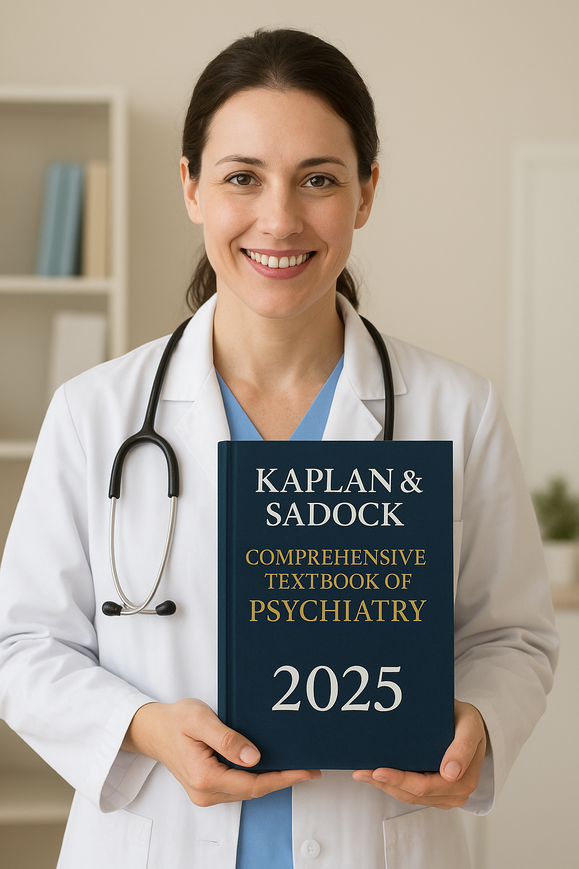

راه‌های دانلود :

1. QR code



1. لینک دانلود

[https://s34.picofile.com/file/8486647084/GINA_2025_Estrategia_global_para_el_m%20%20%20anejo_y_la_prevencio%CC%81n_del.pdf.html](https://s34.picofile.com/file/8486831018/Kaplan_Sadock%E2%80%99s_Comprehensive_Textbook_of_Psychiatry_Vol1_2_Robert_J_Boland_M_D_Marcia_L_Verduin_M_D_compressed_1_.pdf.html)